Hey everybody, and welcome back to my channel. Sorry about the air conditioner in the background, but there’s nothing we can do about it.

嗨，大家好，歡迎回到我的頻道。抱歉，背景有冷氣的聲音，但是我們沒辦法處理。

Um, today I want to talk about my lat injury and reattachment and kind of what I think caused it and the recovery process and the therapy I’ve been doing to get better from it. So let’s start with how I think it happened.

今天我想要講有關於我的背肌受傷和重新附著，和我想造成的原因及復健過程和我一直在做的療程，來變得越來越好。所以讓我們開始來說，我覺得是怎麼發生的吧。

About three weeks out from the US open(Kernusopen), I pulled 820 in training. It was good, I mean, it felt great. Pulled it right up, no problems. Figured I was good for 859 on a third and that was kind of the plan going into it: take a nice light opener, pull a new world record and then try to break it even further with that.

在美國公開賽前三週，我在訓練中拉出820磅(371.95公斤)，這很好，我的意思是感覺很好，把它拉起來很容易，沒有問題。我認為第三次拉859磅(389.6公斤)沒問題，這就是其中的計畫，輕鬆的開場白，舉起一個新的世界紀錄，然後嘗試舉得更重去打破紀錄

Um, clearly the last part of that didn’t happen, because I tore my lat off at the 821, but we’re three weeks out. I had the great training session, and then the next day I go to visit the World Buddhism Association headquarters in Pasadena; I go to visit my Buddha Master, Namo Dorje Chang Buddha III.

嗯，很明顯，最後一部分沒有發生，因為我在 821磅撕裂了我的背闊肌。

在我們離美國公開賽的三個星期前，我有很棒的訓練課程，然後第二天我訪問位於(美國洛杉磯)帕薩迪納的世界佛教總部，我去求見我的佛陀師父 南無第三世多杰羌佛。

And there’s a bunch of Vajra Scepters laying around now, Vajra Scepters look like a giant Thomas inch dumbbell; they’re much heavier and the handles are a little bit thinner. But they’re huge-looking, really neat, uh, implements.

有一堆金剛杵現在躺立在那裡，金剛杵看起來像一個巨大的「湯瑪斯英奇啞鈴」(知名於重約172磅(78公斤)，把手厚近2 3/8英寸，如果沒有強大的握力，無法抓住它) 。但它們重得多，手柄稍微薄一點，然而這些杵看起來很大，真的很酷的器具。

And I lifted them all except for the Buddha Scepter. The only person that’s ever lifted the Buddha Scepter is Buddha Master, and basically that is 59 levels over what is normal for people that Buddha Master did when He lifted that. And being a Shangzun, I thought I had a good shot at it. So I went and grabbed it and started pulling on it, and he warned me not to do it but I gave it a try and I pulled with everything I had. And then I felt like a movement or a twinge in my lat, and I was like kind of “It was painful, but it wasn’t bad," and He was like “I wouldn’t compete in three weeks." I go, “I think I’ll be fine; I got three weeks to heal, it should be okay." Well, didn’t listen, tore it off. um with a weight that I can easily accomplish.

我把它們都提了起來，除了佛陀杵。唯一曾經能提起佛陀杵的是佛陀師父，佛陀師父提起的基本上比正常人上超59 段。而作為一個上尊，我想我應該有機會拿起來。所以我走過去抓住它，並開始拉起佛陀杵。佛陀師父警告我不要拿，但我仍去嘗試，我用盡所有力氣去提，然後我覺得我的背闊肌移動了或覺得有刺痛，而我覺得好像是會疼痛但不差。佛陀師父說，如果我是你，我三週內不會去參加比賽。我說，我想我會沒事的，我還有三週可以恢復，應該可以。嗯，我沒有聽佛陀師父的話，結果背闊肌撕裂，在我原本可以輕易完成的重量。

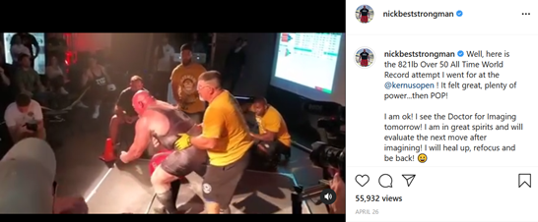
旺扎上尊IG (歡迎訂閱關注)

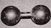 Thomas inch dumbbell 湯瑪斯英奇啞鈴

